Making Your Voices.com Profile More Marketable

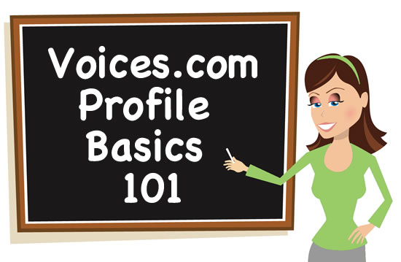
Do you know how your Voices.com profile appears to prospective clients?
You'd be surprised by how many talent add content to their profile and don't take a look at how the information displays on the site.
If you're one of these people, (or even if you're not!), this article will give you some insight on how evaluate your profile and fine tune it to better attract customers online.

Getting To Know Your Voices.com Profile
As you know, your profile comprises of 3 sections which are:
๏ Profile
๏ Demos
๏ Feedback
We'll be focusing on the main profile page in this article and walk step by step through how to make it both attractive and informative for people visiting your profile at Voices.com.

Main Profile Page
Your main profile page can be viewed by going to: http://yourusername.voices.com
A good example of a completed Voices.com profile can be found here:
http://bobbinbeam.voices.com
You might notice that the page redirects to:
http://www.voices.com/people/bobbinbeam
The shorter more personalized version is for you to use when promoting yourself on your business card or when social networking. Keep in mind that the URL structure does change once people are on your profile to better organize how profiles are displayed.
Here is the structure for each page (URL) of your Voices.com profile:
http://www.voices.com/people/yourusername
http://www.voices.com/demos/yourusername
http://www.voices.com/feedbacks/yourusername
The first page is an overview of all that you can do and prominently features your Primary Demo, your most recent feedback rating and review (if applicable), and more. Here's a rundown of all of the fields that appear on this page:

Highlights
This section is where you can write about your voice. The Description field in particular is meant to share information about how your voice sounds, any special skills and so on. Personally, I'd take the opportunity to sell your signature or "money" voice in this field to begin with and then leave subsequent sentences for describing voices you can do but aren't hired for as often.
Languages
Within your account, you can choose up to 5 (five) languages. They should be selected in order of fluency from most fluent (for example, your mother tongue and dialect if applicable) to least fluent (languages or dialects you've learned in addition to your primary language). This may go without saying but it makes a great deal of sense to have an audio sample on your profile that reflects your language selections.
Accents
While not everyone does accents or character archetypes, what you should list is at least your regional accent or state that you have a neutral accent relevant to the country in which you live. For instance, if you are in the US and you sound like you have an accent that sounds "neutral," you could say that you have an NPR (National Public Radio) voice. If you're in the UK and your accent or manner of speech can be referred to as RP, be sure to list it! Specifics mean a lot when it comes to being found. Adding content to this field also helps you edge toward Profile Completeness.
Ages
Voice ages are very important to list. When a client visits your page, they can get an appreciation for your range quickly given this area of your profile is completed. Remember to only select voice ages you can confidently and believably do. Featuring demos that showcase each voice age you selected is also beneficial to those visiting your profile.

Experience
Experience can be anything you have done up to this date that lets people know where your expertise and talents lie. This means that if you have a degree in a field unrelated to voiceover, you could still benefit from mentioning it! You never know when someone will need a voiceover recorded that is related to an area of work experience or personal interest.
Years of Experience
This refers specifically to industry experience in voiceover. I've seen a lot of people say that they have substantial experience but they fail to list what it is they've been doing for those years! If you filled this field out but neglected the actual field where you can input text describing your experience, go back now and paint a picture of what you were doing during that time to better promote yourself.

Special Skills
Your special skills directly relate to the categories you are able to record voiceovers for. Some of these may include Cartoons, Movie Trailers, Documentaries, Audiobooks, Business, Educational, Radio, Telephone, Podcasting, Television and Internet. There are currently 14 categories to choose from. Again, it makes sense to have demos that reflect these special skills so be sure to get more samples of your voice uploaded to the site for prospective customers to hear.

Credentials
This area is where you can talk about the schools you have attended and so forth.
Education
All forms of education are welcome in this field! Consider adding details about workshops you have participated in, teachers you have studied with and post-secondary programs you have completed.
Associations
This field allows you to mention any union or guild affiliations that you may have (or may not have!). Be sure to complete this in order to have jobs sent to you for work that you want to audition for as this field helps determine the job invitations you receive.

Studio
In the studio section, you can detail your equipment and software, specifically your:
๏ Microphone
๏ Computer and software
๏ Special equipment
๏ Delivery methods
๏ Turnaround time

Detailed Service Description
What is it that you can do for your clients that sets you apart? This field is where you can elaborate on a more detailed service offering and share information about how you can deliver on your brand promise.

Payment Terms
This section is where you can let people know how you'd like to be paid for your work. Accepting funds through the SurePay escrow service at Voices.com is a good option to include as most clients using the site will appreciate seeing it present on your list. If you prefer to give more than one payment option, you're welcome to include other methods as well.
For more information:
http://blogs.voices.com/voxdaily/2011/05/voices-com_profile_tips.html

